Programming in C – BitManipulations

**In this you can find a project that contains a skeleton with basic methods that perform al kind of bit manipulation operations.**

****Project overview****

****In the picture below you can see the project structure.****

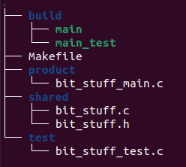

**Please implement all functions in bit_stuff.c. A set of unit-tests is already available in bit_stuff_test.c.   
  
You can find more information on the functions in the header file (bit_stuff.h).**

**Build Instructions**

Open a [terminal](https://www.google.nl/search?q=linux+using+a+terminal) and go to the directory that contains the Makefile.

The table below provides a overview of the possible build commands:

|  |  |
| --- | --- |
| **Build instructions** | **Description** |
| make | Builds the executable ‘build/main’.  You can run it from a terminal with ./build/main. |
| make test | Builds and runs an executable ‘build/main_test’ containing the unit-tests.   You can run it from a terminal with ./build/main_test. |